**Experiment – 6**

**DML COMMANDS (COLLEGE SCHEMA)**

**Aim:**

* Insert 5 instances into the tables created in experiment 6.
* Display the tables.
* Add attribute course to student table then insert values.
* Use update to set course for students.
* Delete an attribute.

**COMPONENTS**

* DML (Data Manipulation Language): The SQL commands that deals with the manipulation of data present in the database belong to DML or Data Manipulation Language and this includes most of the SQL statements.
* Examples of DML:
* INSERT – is used to insert data into a table.
* UPDATE – is used to update existing data within a table.
* DELETE – is used to delete records from a database table.

CODE WITH SOLUTION:

* Insert 5 instances into the each table and display

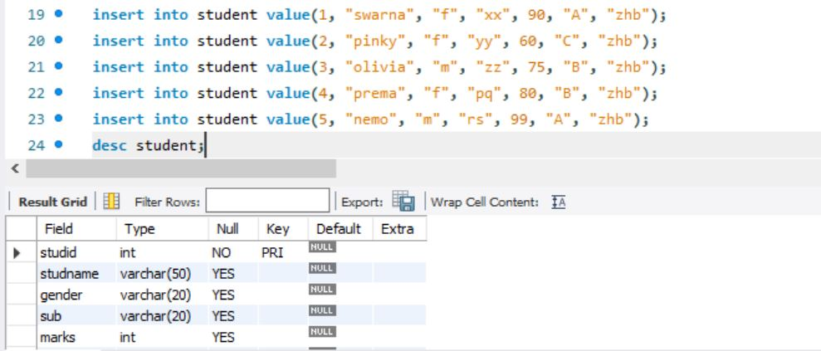

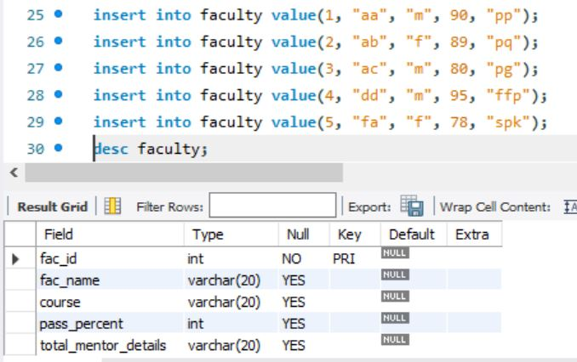

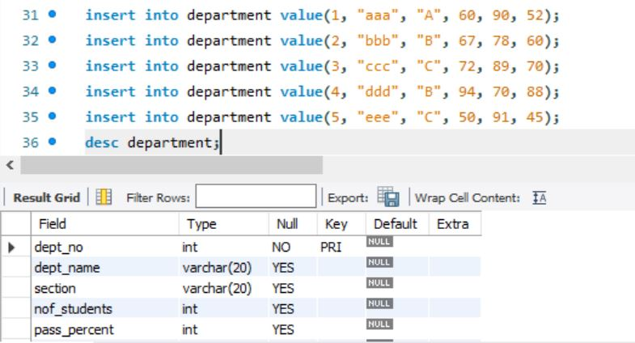

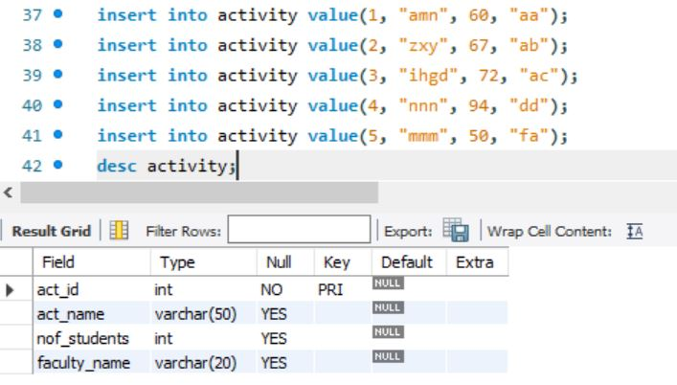

* Display tables

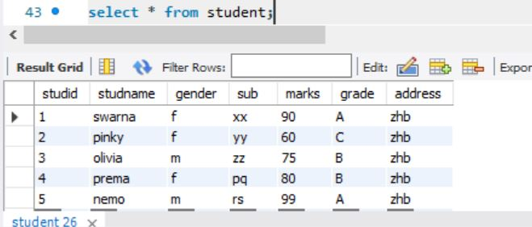

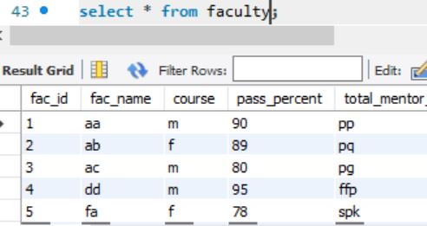

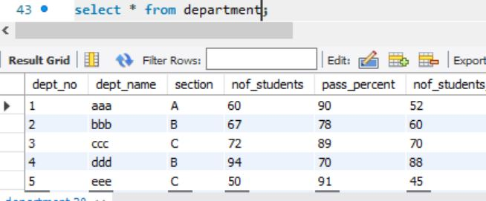

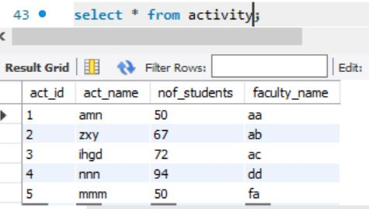

* Add attribute course to student table then insert values
* Use update to set course for student

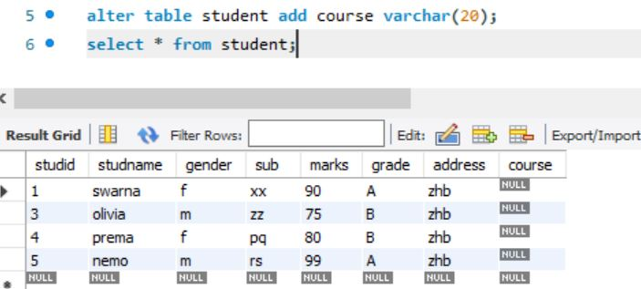

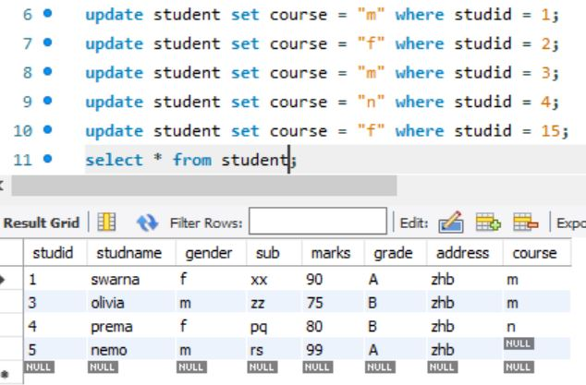

* Delete an attribute

